170

Using the keypress event listener to make sound from clicks



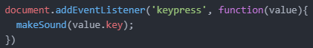

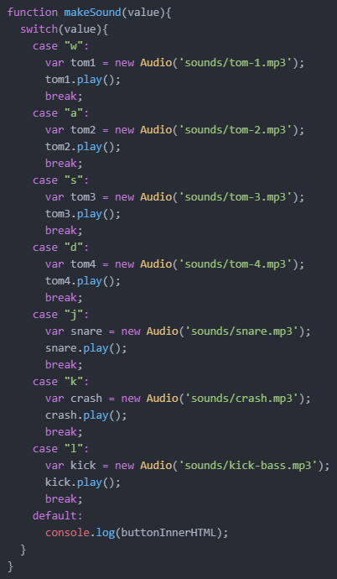

Callback function

* The function that is called when the keypress occurs
* On the example below, it is the ‘respondToKey(event)’ function

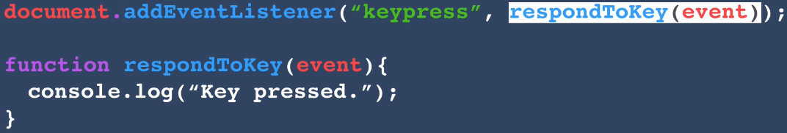

A sample function that demonstrates how the addEventListener works

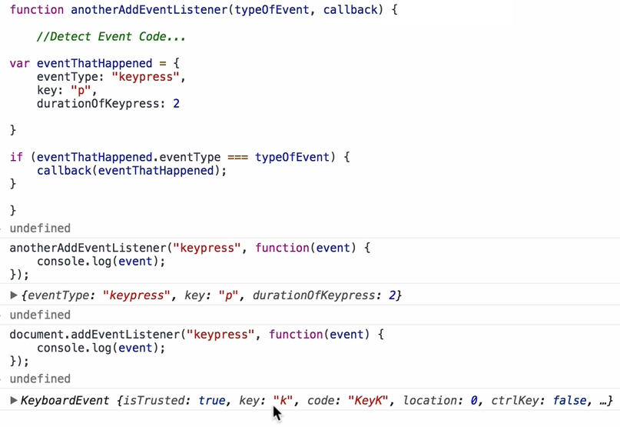

.classList

-contains all the classes that are applied to a particular tag



.classList.add(“pressed”)

-adds the “pressed” class to the element

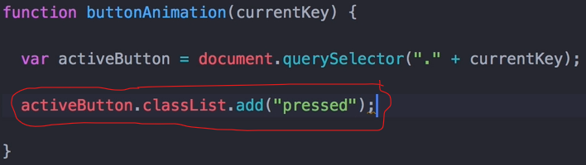

setTimeout

* The time specified defines the time we will have to wait before the function inside the setTimeout gets executed.

